Re- Entry Implementation for School Authority
Shared Responsibility is a commitment among education stakeholders -
Alberta Education staff, jurisdictional and school leaders, teachers,
professional learning providers, students, parents, and school councils –
to develop a shared understanding of and commitment to their respective
roles and responsibilities to support implementation. In some cases
education stakeholders’ implementation support responsibilities might be
shared, in other instances they will have distinct responsibilities.
Who is involved with developing this implementation plan?
e.g., system team? ATA? CUPE? School Leaders?
How have we engaged the community?
RE- entry re survey?
Your school authority logo here.

Essential Condition | Outcome  (Measurable result) | How will we find out if our efforts are having an impact? What measures will we use?  What will we accept as evidence of implementation? | Actions /Strategies/Outputs to address this essential condition/outcome (and achieve the outcome)
Shared Vision  Stakeholders share an understanding of and commitment to the intended outcomes.  e.g. Re-Entry provides Students and staff with a safe and well environment that supports optimum learning for all.  How will our re-entry plan leverage our school authority vision/mission? | Student learning  Wellbeing  (staff and students)  Operations
Leadership
Leaders at all levels have the capacity to champion the shift from the current reality to the intended outcomes.
e.g. Leaders are adaptive, responsive and supportive of staff and students needs during re-entry.
Research and Evidence
Current research, evidence, and lessons learned inform implementation decisions.
e.g. Access and use of Alberta Education resource materials and CASS colleagues have informed our plan.
Resources
Human resources, materials, funding, and infrastructure are in place to realize the intended outcomes
e.g.
Resources for re-entry have been allocated for and are accounted for.
Teacher/Leader Professional Growth
Teacher/leader knowledge, skills and attributes are enhanced through ongoing professional learning.
e.g. a Comprehensive professional learning plan has been designed.

Time
Time is provided to support implementation.

e.g. Given context “re-entry” will be complete by….

Community Engagement
Parents, school councils, students, community members, businesses, industry and post –secondary institutions are partners in supporting implementation.

e.g. We have engaged our community by….

Culture of Learning
A culture of learning is a social/emotional environment in which inquiry, risk-taking, sharing and collaboration are encouraged in order to optimize student learning. What will we accept as evidence that our context models a strong culture of learning based on a shared responsibility to support implementation?
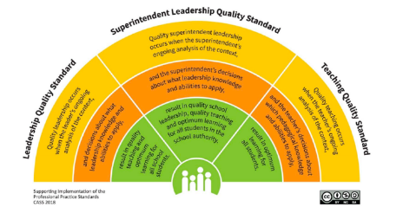
Quality Superintendent Leadership occurs when the superintendents ongoing analysis of the context, and the superintendent’s decisions about what leadership knowledge and abilities to apply, result in quality school leadership, quality teaching, including a focus on safety and wellbeing resulting in optimum learning for all students in the school authority.

