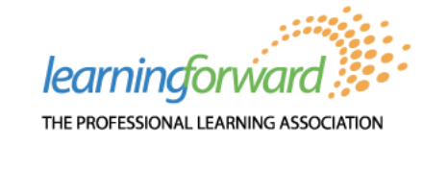
How Professional Learning Improves Teacher and Student Outcomes: Examining the Evidence

Webinar Recording: https://us06web.zoom.us/rec/play/iuRsimNMo9VVWhdi6klxhTvFRzZM1gMhMMoOFykRYTkGS1_fQ7WVyqrbucK6bqWX-5LwMJdL8Zn5rFff.uQlLAn0P7xAL1Ahp?continueMode=true

Register to gain free access

Slide Deck:
https://learningforward.org/wp-content/uploads/2023/03/WebinarFinal_3-2-23.pdf?utm_source=Informz&utm_medium=Email&utm_campaign=various_promos&_zs=RUg3f1&_zl=dorq8

Research Updates about effectiveness of Professional Learning via Title II website
https://poweredbytitleii.com/

Learning Forward Organization
https://learningforward.org/
Discount for Individual memberships
Register for membership here:
https://learningforward.org/membership/
Enter coupon code
https://learningforward.org/membership/
ABCONF23EF

Additional Learning Forward resources mentioned in the webinar:
- Experience high-quality professional learning with our upcoming online courses!
- Learn more about the research behind Standards for Professional Learning.
- Read articles from our latest magazine issue: Tackling Turnover.
- New book: Action Guide for the Principal
- Read our latest blog posts.
- View upcoming webinar topics and archived webinars.
- Get $10 off any new Learning Forward membership using the code: LFWebinars

